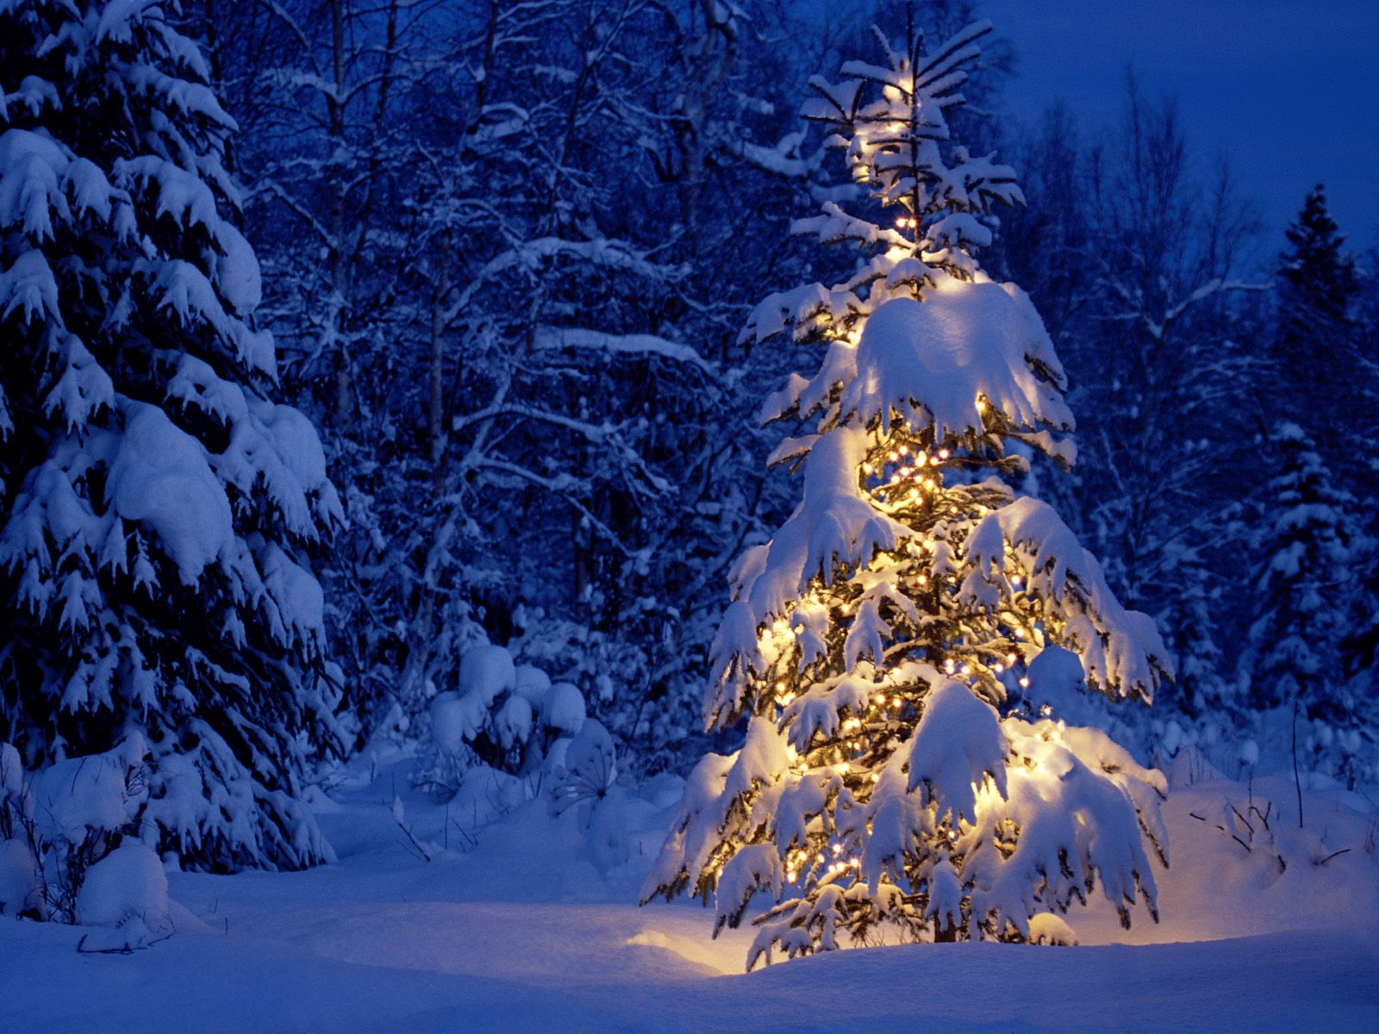

***Please place your order in advance***

***Cost of $65.00 each***

***Choice #1***

* ***One Chub***
* ***One Skalondi***
* ***Four Assorted Beef Stix***
* ***One Block of Smoked Cheese***

***Choice #2***

* ***Three Assorted Flavors of Jerky***
* ***Two Assorted Blocks of Smoked Cheese***
* ***One Container of MCF Jerky Dip***

***Miller Charm Farm***

***Holiday Gift Boxes***